Wellfleet Police Department
Citizens Police Academy
Application
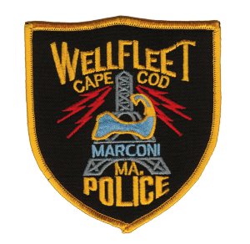
Session #1 March 27th, 2019-May 8, 2019
Classes will be held on Wednesdays 6-8:30PM
Name:__________________________________________________________________
Address:________________________________________________________________
SS#___________________________________Date of Birth:______________________
Home Phone:_________________________Work Phone:_________________________
Email:__________________________________________________________________
Occupation:______________________________________________________________

Why do you wish to attend the Wellfleet Police Department Citizens Police Academy?_______________________________________________________________ ________________________________________________________________________
________________________________________________________________________
I authorize the Wellfleet Police Department to conduct a criminal history check for the purpose of making a determination of eligibility for the Citizens Police Academy.

Signature:_____________________________________Date:_______________________
If you have any questions please contact Sergeant Paul Clark at the Wellfleet Police Department 508-349-3702.
Paul.clark@wellfleet-ma.gov

